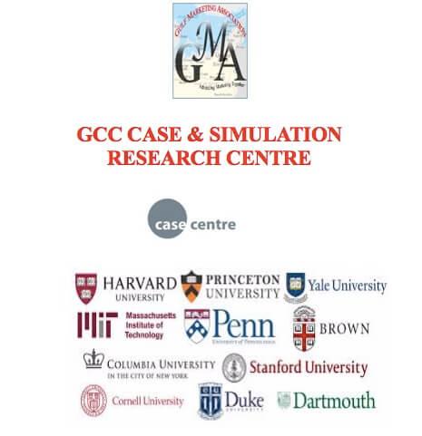
In recent years, GCC has emerged as a regional alliance of strategic importance, economic potential and constant growth. The UAE for instance has consistent been growing around 4% even in the midst of emerging oil price declines. The award of the Expo-2020 has brought enormous expectation in economics and multiplier impacts.
Disappointingly, however, the universities and teaching colleges in the GCC region suffer from the shortage of region relevant teaching and learning cases and simulations, collaborative learning and engagement among faculty and learners, authentic applied research, industry-academic cooperation and individual case research and writing initiatives and insights. GCC schools, colleges and universities teach predominantly on the western cases and experiences.

Vision
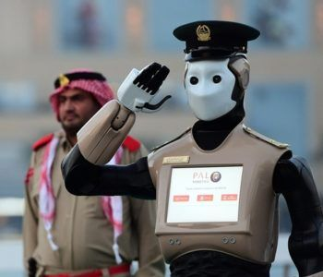 The GCC Case & Simulation Research Centre envisions aims to be the ‘New Game Changer in applied teaching and learning in business education in the GCC region.’
Mission
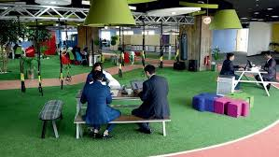 Towards accomplishing the vision, the GCC Case and Simulation Research Centre ‘will strive for early recognition as the most respected Research and Repository for business Simulation & Case research, teaching and training in the GCC with a spotlight on the UAE’.
Activities
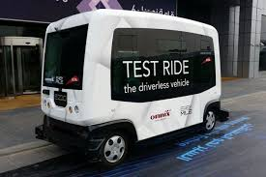
- Case writing and teaching workshop to promote, publish, diffuse simulation an cases relevant for GCC, short case and game summaries, teaching notes that foster learning live.
- Train the trainer workshops, seminars, symposium for case and simulation researchers.
- Invite case funding, sponsorship for professionals around the world to conduct and publish case and simulate research at the centre;
- Position Dubai as the world city of applied and engaged learning in business knowledge.
- All other activities that help accomplish our vision and mission.
Current Case Portfolio
The GCC Case center has continuously published and hosted a healthy portfolio of teaching cases including the following: (Abstracts and full list on request)
- Dubai Chamber of Commerce -Duopoly
- Dubai Electricity and Water Authority- Sustainability
- Dubai Police- Robocop
- Dubai Delivers Coffee and News -instantly
- Event Marketing in an Higher education
- Gold ATMS in UAE
- Knowledge and Human Development Authority (KHDA) – Physical servicescape
- Road and Transport Authority – Smart Cars
- Weekly Promotions war in Dubai Supermarkets
- Sharjah Electricity and Water Authority- Service Model
- Young Entrepreneurs in Dubai – Food trucks Salt
- The UAE Ministry of Possibilities- Innovation

[space height="10"]

Advisory Board
Chair

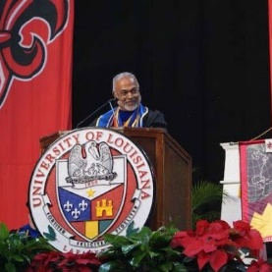
Dr. Joby John, Professor
Dean, College of Business Administration,
University of Louisiana USA
Members
- Dr. Ali Al-Qayedi
General Manager, Etisalat Academy
Dubai, United Arab Emirates
- Mr.Ashish Asthana
Director, Marketing, Growth Portfolio & Innovation Coca-Cola
Dubai, United Arab Emirates
- Dr.Dominique Lecossois
INSEAD Distinguished Executive Fellow-Emerging Markets Institute,
Advisory Board Member, Singapore
- Dr.Mohan Lal Agarwal
US Fulbright Fellow
Dubai, United Arab Emirates
- Mr.Mahmood Al Bastaki
Chief Operating Officer
DT World, DP World
Dubai, United Arab Emirates
- Ms.Poonam Datta
Chief Executive Officer
IMC Maritime, Logistics & Supply Chain
Dubai, United Arab Emirates
- Dr.Svend Hollensen
Professor and celebrated author of Global Marketing
Southern Denmark University, Denmark

