**UGC NET -** We rank among India’s top 5 UGC NET Coaching Centers.

UGC NET or the University Grants Commission National Eligibility Test (NET) is conducted for determining the eligibility of Indian nationals for the Eligibility for Assistant Professor only or Junior Research Fellowship & Assistant Professor Both, in Indian Universities and Colleges. UGC-NET is conducted twice a year. In June 2020, the examination is scheduled between 15 June and 20 June 2020.



## Eligibility Criteria:

Those who have completed their Master’s degree minimum 55% marks for the General category and 50% for ST, SC category can apply for the examination. In fact, those who are pursuing the Master’s degree wile b considered eligible for appearing in the exam.

**Age Limit:**In order to appear in the Junior Research Fellowship, candidates need not be more than 28 years of age. However, if there is some age relaxation then it will be according to govt. rule. For Lecturer-ship, there is no particular age limit.

## UGC NET Syllabus:

The UGC NET 2022 Syllabus depends on candidates because candidates choose the subject. More than 100 subjects included in the UGC NET entrance exam. UGC NET exam divided into two parts that are Part I and Part II. Part I syllabus will common for every student. The topics will be included in part I such as comprehension, reasoning ability, general awareness and divergent. The part II syllabus depends on candidates selected by the subject.

## Exam Pattern:

The National Eligibility Test (NET) is divided into two parts. The exam conducted in two sessions and candidates must have clear both parts of an exam. UGC NET 2022 entrance exam no negative marking. Each question will be 2 marks.

## Paper 1 Will Be as Per Below:

|  |  |  |
| --- | --- | --- |
| **Section** | **Questions** | **Marks** |
| Teaching Aptitude | 5 | 10 |
| Research Aptitude | 5 | 10 |
| Reading Comprehension | 5 | 10 |
| Reasoning (including Maths) | 5 | 10 |
| Logical Reasoning | 5 | 10 |
| Data Interpretation | 5 | 10 |
| Information & Communication Technology (ICT) | 5 | 10 |
| People & Environment | 5 | 10 |
| Higher Education System: Governance, Policy & Administration | 5 | 10 |
| **Total Marks** | **50** | **100** |

**Why Coach at the Multinational Business Academy**

We are run by faculty and alumni of XLRI Jamshedpur. We believe in quality of education and teaching. Our faculty believes in imparting not rote techniques but concepts. That’s why we have our unique team which devotes fully to prepare excellent material. Our material is fully compatible to new NET Syllabus. We coach UGC NET coaching in Computer Science, Economics, commerce, HRM, Management etc.

**Classroom Program:**

* Classes scheduled on week days /week end
* Complete Study material    + All India Test Series + Practice test papers and solved papers of last 5 years

**Correspondence Program & Online Test Series:**

* Complete Study material + All India Test Series + Practice test papers, Question Bank with solved answer.

**UGC Net Coaching Material**

MBA Academy provides its own course material relevant for UGC Net Exams. Our course material is a compilation of various sources of information from books, internet and improved by our expert groups of teachers, who have years of experience in UGC Net. Our material has been sought after from all parts of India and overseas.

MBA Academy has launched India’s first ever online learning course hosted on world-class Blackboard learning system. Enroll below to our Paper 1 and HRM online course by paying an affordable enrollment fee for online study including reading on mobile and tablet. Available online courses: Paper 1, HRM and Management (Commerce coming soon)

The online course for Paper 1 and HRM includes Lecture Notes, Lecture Slides for all 10 units of Paper 1 syllabus and HRM full syllabus. In addition, you will also get access to one full lengths mock test paper plus answer keys to three UGC NET papers from previous years. The advanced online learning platform of Blackboard allows you to join discussion forums with other UGC Net students or post questions to be answered by our classroom teachers.

Please [contact us](https://multinationalacademy.com/?page_id=100)for more details. Fees for Paper 1 online learning is Rs. 2700. Fees for HRM online learning is Rs. 2700. Payment can be made through any of the methods described above (bank transfer, cash payment at our office) or online through PayUMoney or PayPal using buttons below. Post payment, please contact us to receive your user login details.

UGC Net coaching material is offered in two packages Basic and Premium

Basic Package – Rs 6950

This includes material, courier charges for delivery anywhere within India.  Delivery outside India would cost extra.

Basic + Video Package – Rs 7950

This includes material + **Videos.**The videos include UGC net study tips plus course summary for Paper I by our qualified UGC Net faculty. Postal charges for delivery included anywhere within India. Delivery outside India would cost extra. The above packages also include online mock UGC NET sample papers. Upon order, user id and password will be sent to you to access them. Results available to you instantly

**How to Order –**You can pay online through Pay Money (For Indian rupees) or PayPal (secure online transfer in USD using any credit card or your own Pay Money or PayPal account.

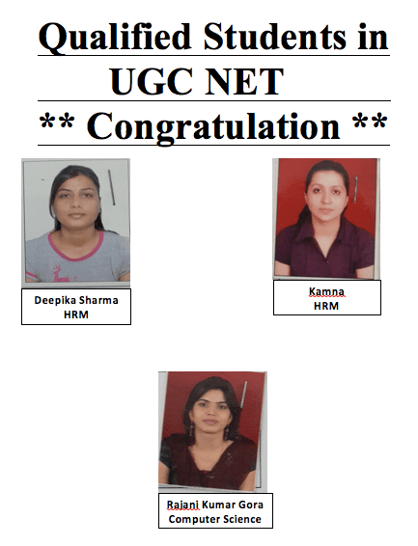

**UGC NET Frequently Asked Questions**

**1. Why should I join UGC NET coaching?**

UGC NET exams are increasingly getting more competitive and more demanding. Structured coaching targeted study material, experienced faculty is essential to qualify in the first attempt.

**2. Why should I coach at Multinational Business Academy ? What is your success ratio?**

Multinational Business Academy is among the top five UGC Net training centers. Our faculty is NET qualified and experienced in teaching at XLRI Jamshedpur etc. Our Success ratio is 80%.

**3. What does classroom coaching comprise?**

Classroom coaching is held on all days of the week for Paper I, II and III. Duration of the program is to complete the subject with time devoted to each of the papers for a complete preparation.  Students are encouraged to ask questions and seek clarifications on any areas of the subject. Coaching syllabus is based upon the UGC NET required syllabus available on their website.

**4. Which subjects are available for classroom coaching?**

Classroom coaching is available for Paper I, English, Management, Commerce and Computer Applications. Students, who wish to pursue coaching in other subjects, please email to [contact@multinationalacademy.com](mailto:contact@multinationalacademy.com). Classes are subject to availability.

**5. Can I register for classes for only Paper I or Paper II and III?**

Yes, you can and you should.

**6. I am interested only in the coaching material without the classes. Is that allowed?**

Yes. You are welcome. Multinational Business Academy mails its copyrighted coaching material under “Correspondence Programme”. Registered student can login and do all exercises with the help of faculty without classes. Material are complied and as per the Net syllabus

**7. When do classes start?**

Batch starts in January, April, July and October of each year. Students are encouraged to join at the start of each batch. In case you have missed the batch starting date, you can still join and make up the earlier portions in the next batch.

**8. How much are the coaching fees for the classroom and the correspondence** **programme?**

Our lowest Fees and other details are available in the puff on our website. We are the lowest in the country.

**9. Do you provide accommodation facilities?**

Yes we do. Multinational Business Academy has tie-ups with external PG and hostel providers for boys and girls.

**10. How do I apply?**

WhatsApp +91 9810247291 or Email [contact@multinationalacademy.com](mailto:contact@multinationalacademy.com)