Job Placement in India
Multinational Business Academy has an exciting band of recruitment and industry partners through which internship, project learning and job placement is assisted to our students. Only fully trained, sincere and disciplined students are offered to the industry for training & placement so that they become future brand ambassadors. The Academy also offers international study abroad opportunities in the UAE, USA, Taiwan and many other countries to those students who show hard work, academic sincerity and work ethics.
“Learn and Earn and Extra Employability"
Our students acquire a comprehensive range of analytical, problem-solving and professional skills, which are increasingly valued in the industry, and in other areas of commerce, education, government and non-profit making organizations. Success at the Academy is a key to pursue management career in national and international firms, super-specialization and retail Management for extra employability and join the growing field of banking, insurance, real estate, media, consumer products, services and technology.
MBA has brand association with Amrapali Group of Industries, Mico Bosch, LG India, Dell Computers, Reliance Capital, ICICI, MAX Life Insurance, Kotak Mahindra, Pantaloon, Shoppers Stop, Trent, Subhiksha, Life Style, Barista, Cafe Coffee, Titan, Bata, West Side, NIIT, Aptech, Escorts Group, Fortis Hospitals, GNRC Heart Institute, IDEA Telecom, Airtel, Times of India, Indian Express, NDTV, Zee TV, Sony Television, DLF, Ansals, Amrapali Group, OMEX, Bajaj amongst many others .Some of them are as follows:
Placement Cell
- 100% Placement assistance
- Company based training
- Regular Students monitoring Team

Flow Diagram of our Placement Cell:
Step I
- Strength identification & nourishing communication Skills.
- Presentations (paper & PowerPoint) .
- Seminars.
- Communication Development programs.
- Personality Development class.
Step II
- To give corporate exposure through industrial visits.
- Personality Development workshops.
- Guest Lectures from Corporate.
Step III
- To train to face the forthcoming placement.
- Group Discussions.
- Mock Interviews with industry people.
- Value added courses.

Final Step
- To map the organizational expectation with the existing competencies .
- Student-Corporate interactions.

Summer and Winter Training in India and Overseas

The basic idea of Summer Training is to expose students to real world of corporate life. It gives students an opportunity to apply the knowledge and skills in the real problem and also helps them understand the balance between theoretical inputs and corporate practices. The summer internship starts in the beginning of June and December and the duration is generally eight week.
The placement cell of the institute along with the support of the faculty provide necessary support in the final placement of the students.
Some of our students who found jobs because of our training, placement efforts and extra employability are as follows:
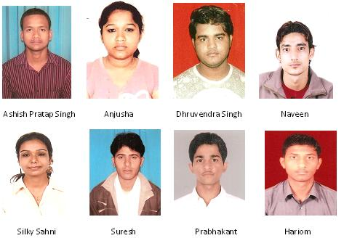
Some of our MBA Students........
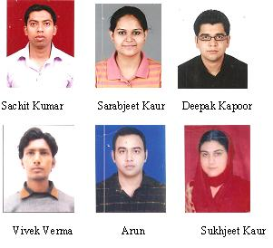

Some of our CRM Students.......
Some of our Phd Students…..

Our Internship students......
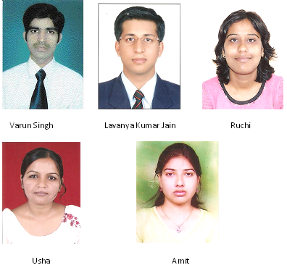
Some of our exchange students..........

