CTET Exam (Central Teacher Eligibility Test) or State TET
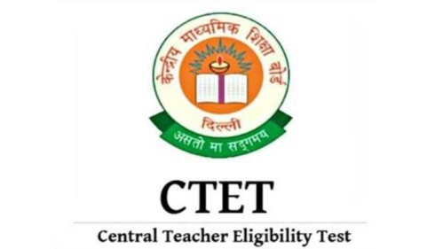
Looking for an attractive career in teaching? Well, teachers are highly respected in our country. The world has become highly competitive in nature. Hence with growing competition what is essential; is the fact that everyone needs to prove his or her potential to achieve something. The aspiring people looking forward to teaching profession has to successfully clear the Central Teachers Eligibility Test to qualify as a teacher in any reputed Government or Private schools of our country?
We provide a variety of courses to cater to CTET aspirants needs.
MBA Academy will enhance the candidates for CTET exams in the following aspects-
The Institute provides lecture sessions on all the three papers of this exam namely:
1. Paper 1: Child Development & Pedagogy, Math, English, EVS (Environmental Studies) and Hindi
2. Paper II: (Math & Science) Child Development & pedagogy, Science, Math, English and Hindi
3. Paper III: (Social Studies): Child Development & Pedagogy, Social Studies (History, Geography & Civics), English and Hindi
MBA Academy aims at the following areas with their coaching-
1. Expert faculties provide individual attention
2. Faculties Explains concept with practical examples for students to understand
3. Interactive session between students and faculty to clear out doubts
4. Students can assess their progress level with the help of frequent test sessions
5. Students get a recap of all that is covered with the help of revision classes
6. Students get exam oriented class sessions
Course Fees
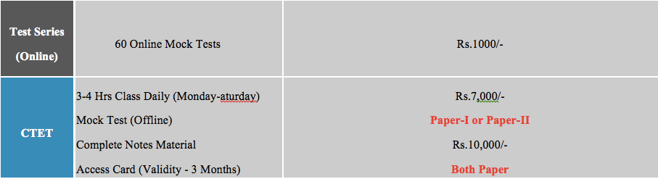
Please note -Revised fees is 8500 for both paper with all test and material, including online tests etc
Regular Classroom Coaching: The flagship program of our coaching in a three month classroom coaching for CTET/TET, which covers all aspects of CTET Exam in detail. Batches are available through the year for this course and students can enroll at any time. Language of instruction is - Hindi and English
Correspondence Course: We also provides correspondence course for CTET and TET Exams with online test series . This is available on English Medium Only.
Crash Course: We also provide a one month crash course for TET and CTET exams, These crash course generally start one month before the exam and course is covered in fast track mode. Our result is 90 %
